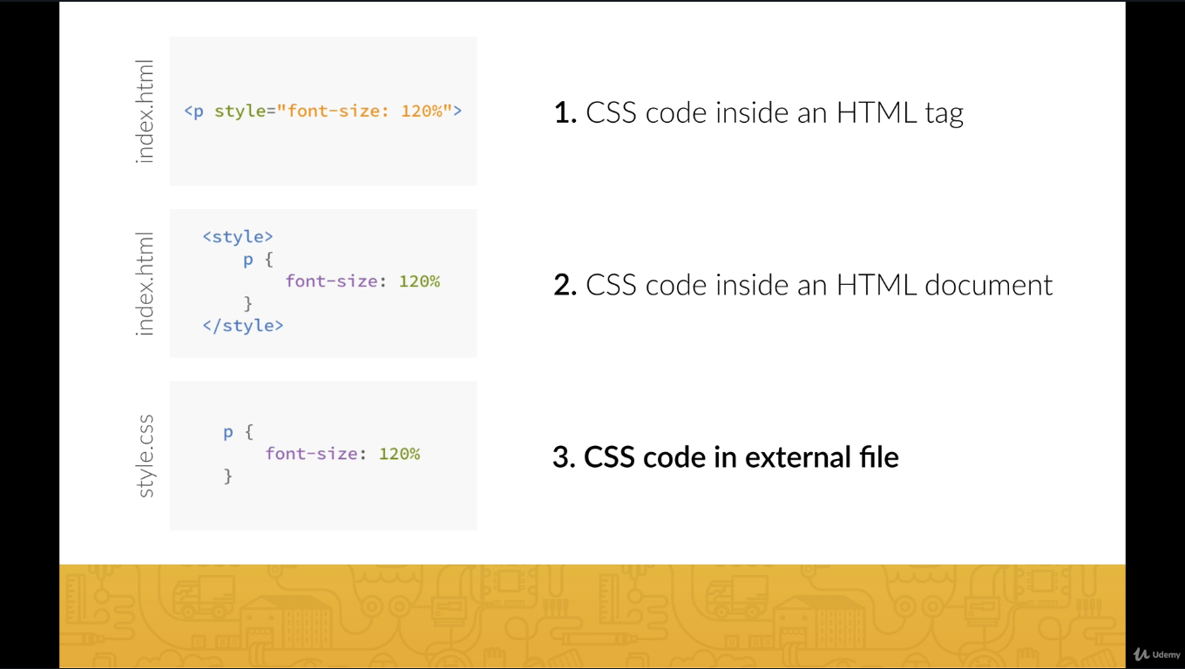

Examples:

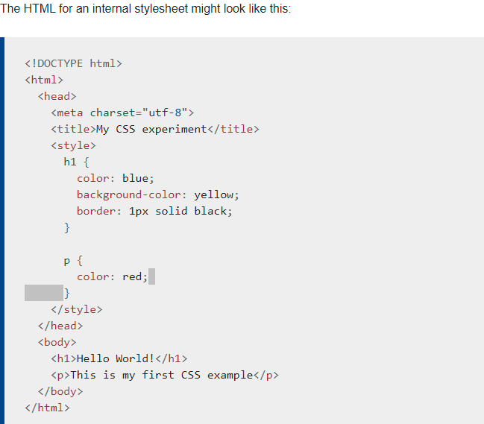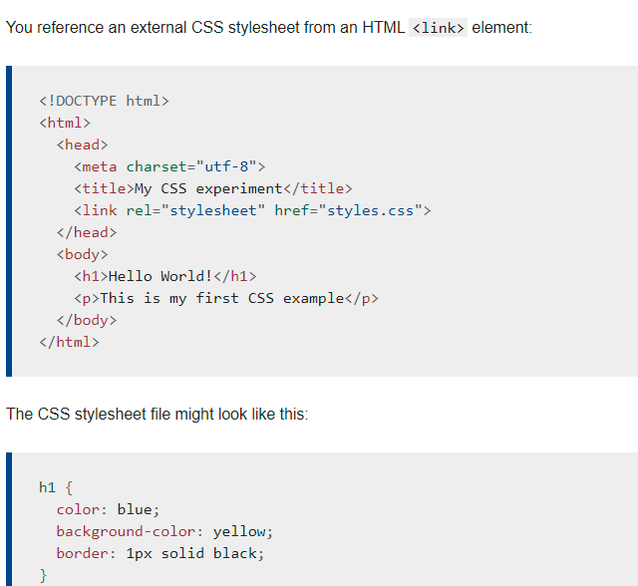

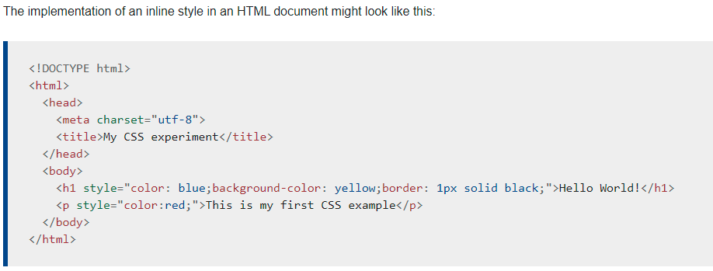

Selectors

## [Types of selectors](https://developer.mozilla.org/en-US/docs/Learn/CSS/Building_blocks/Selectors#types_of_selectors)

There are a few different groupings of selectors, and knowing which type of selector you might need will help you to find the right tool for the job. In this article's subarticles we will look at the different groups of selectors in more detail.

### [**Type, class, and ID selectors**](https://developer.mozilla.org/en-US/docs/Learn/CSS/Building_blocks/Selectors#type_class_and_id_selectors)

This group includes selectors that target an HTML element such as an <h1>.

h1 { }

It also includes selectors which target a class:

.box { }

or, an ID:

#unique { }

### [**Attribute selectors**](https://developer.mozilla.org/en-US/docs/Learn/CSS/Building_blocks/Selectors#attribute_selectors)

This group of selectors gives you different ways to select elements based on the presence of a certain attribute on an element:

a[title] { }

Or even make a selection based on the presence of an attribute with a particular value:

a[href="https://example.com"] { }

Set a background color on all elements that have a class attribute value containing "test":

[class*="test"] {  
  background: #ffff00;  
}

Set a background color on all <div> elements that have a class attribute value containing "test":

div[class*="test"] {  
  background: #ffff00;  
}

## CSS [attribute="value"] Selector

The [attribute="value"] selector is used to select elements with a specified attribute and value.

The following example selects all <a> elements with a target="_blank" attribute:

### **Example**

a[target="_blank"] {  
  background-color: yellow;  
}

## CSS [attribute~="value"] Selector

The [attribute~="value"] selector is used to select elements with an attribute value containing a specified word.

The following example selects all elements with a title attribute that contains a space-separated list of words, one of which is "flower":

### **Example**

[title~="flower"] {  
  border: 5px solid yellow;  
}

[Try it Yourself »](https://www.w3schools.com/css/tryit.asp?filename=trycss_sel_attribute_value2)

The example above will match elements with title="flower", title="summer flower", and title="flower new", but not title="my-flower" or title="flowers".

## CSS [attribute^="value"] Selector

The [attribute^="value"] selector is used to select elements whose attribute value begins with a specified value.

The following example selects all elements with a class attribute value that begins with "top":

**Note:** The value does not have to be a whole word!

### **Example**

[class^="top"] {  
  background: yellow;  
}

[Try it Yourself »](https://www.w3schools.com/css/tryit.asp?filename=trycss_sel_attribute_start)

## CSS [attribute$="value"] Selector

The [attribute$="value"] selector is used to select elements whose attribute value ends with a specified value.

The following example selects all elements with a class attribute value that ends with "test":

**Note:** The value does not have to be a whole word!

### **Example**

[class$="test"] {  
  background: yellow;  
}

[Try it Yourself »](https://www.w3schools.com/css/tryit.asp?filename=trycss_sel_attribute_end)

## CSS [attribute*="value"] Selector

The [attribute*="value"] selector is used to select elements whose attribute value contains a specified value.

The following example selects all elements with a class attribute value that contains "te":

**Note:** The value does not have to be a whole word!

### **Example**

[class*="te"] {  
  background: yellow;  
}

[Try it Yourself »](https://www.w3schools.com/css/tryit.asp?filename=trycss_sel_attribute_contain)

### [**Pseudo-classes and pseudo-elements**](https://developer.mozilla.org/en-US/docs/Learn/CSS/Building_blocks/Selectors#pseudo-classes_and_pseudo-elements)

This group of selectors includes pseudo-classes, which style certain states of an element. The :hover pseudo-class for example selects an element only when it is being hovered over by the mouse pointer:

a:hover { }

p:active, h1:active, a:active {  
  background-color: yellow;  
}

selector:pseudo-class {  
  property: value;  
}

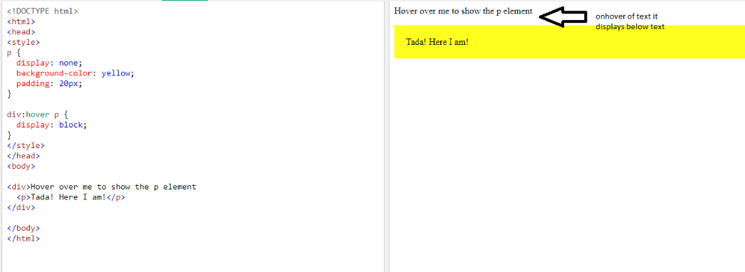

**Pseduo elements:**

## Syntax

The syntax of pseudo-elements:

selector::pseudo-element {  
  property: value;  
}

It also includes pseudo-elements, which select a certain part of an element rather than the element itself. For example, ::first-line always selects the first line of text inside an element (a <p> in the below case), acting as if a <span> was wrapped around the first formatted line and then selected.

p::first-line { }

Insert some text after the content of each <p> element:

p::after {  
  content: " - Remember this";  
}

### [**Combinators**](https://developer.mozilla.org/en-US/docs/Learn/CSS/Building_blocks/Selectors#combinators)

The final group of selectors combine other selectors in order to target elements within our documents. The following for example selects paragraphs that are direct children of <article> elements using the child combinator (>):

article > p { }

A CSS selector can contain more than one simple selector. Between the simple selectors, we can include a combinator.

There are four different combinators in CSS:

* descendant selector (space)
* child selector (>)
* adjacent sibling selector (+)
* general sibling selector (~)

**Descendent selectors**

The following example selects all <p> elements inside <div> elements:

div p {  
  background-color: yellow;  
}

## Adjacent Sibling Selector (+)

The adjacent sibling selector is used to select an element that is directly after another specific element.

Sibling elements must have the same parent element, and "adjacent" means "immediately following".

The following example selects the first <p> element that are placed immediately after <div> elements:

### **Example**

div + p {  
  background-color: yellow;  
}

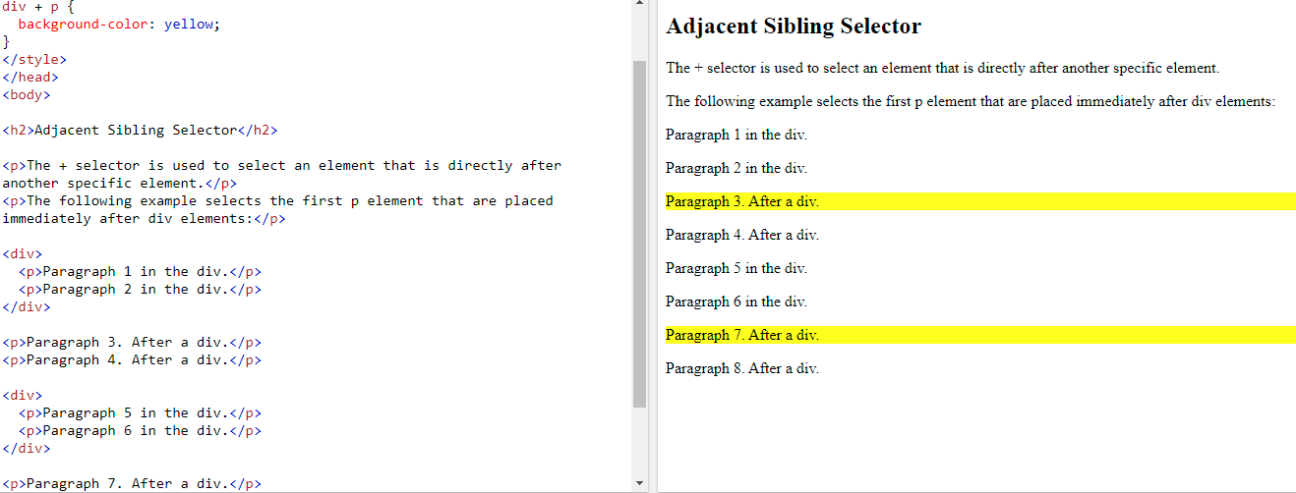

## General Sibling Selector (~)

The general sibling selector selects all elements that are siblings of a specified element.

The following example selects all <p> elements that are siblings of <div> elements:

### **Example**

div ~ p {  
  background-color: yellow;  
}

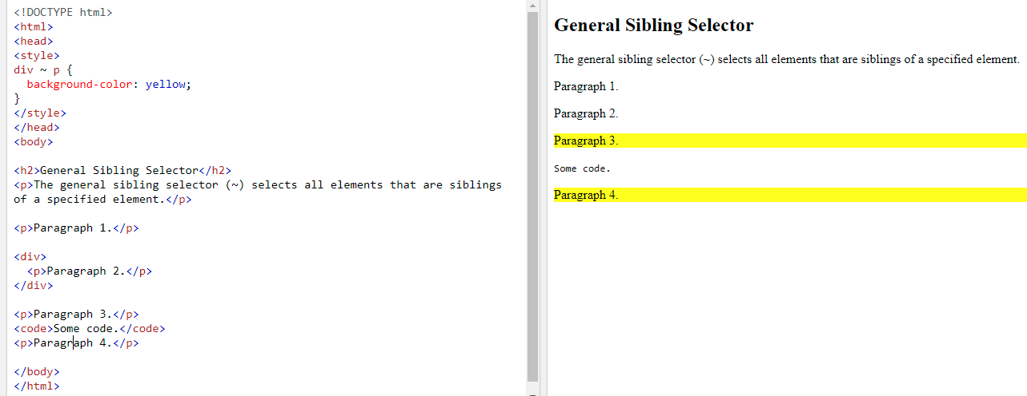

## What is !important?

The !important rule in CSS is used to add more importance to a property/value than normal.

In fact, if you use the !important rule, it will override ALL previous styling rules for that specific property on that element!

Let us look at an example:

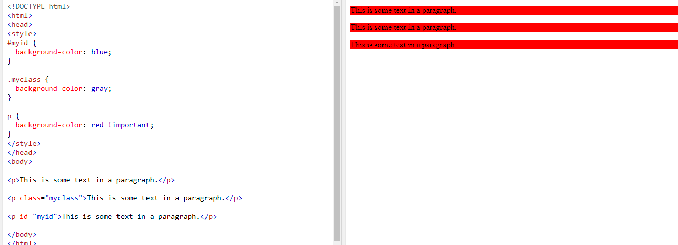

## CSS Units

CSS has several different units for expressing a length

There are two types of length units: **absolute**and **relative**.

Absolute Lengths

The absolute length units are fixed and a length expressed in any of these will appear as exactly that size.

Absolute length units are not recommended for use on screen, because screen sizes vary so much. However, they can be used if the output medium is known, such as for print layout.

|  |  |
| --- | --- |
| **Unit** | **Description** |
| Cm | centimeters[Try it](https://www.w3schools.com/cssref/tryit.asp?filename=trycss_unit_cm) |
| Mm | millimeters[Try it](https://www.w3schools.com/cssref/tryit.asp?filename=trycss_unit_mm) |
| In | inches (1in = 96px = 2.54cm)[Try it](https://www.w3schools.com/cssref/tryit.asp?filename=trycss_unit_in) |
| px * | pixels (1px = 1/96th of 1in)[Try it](https://www.w3schools.com/cssref/tryit.asp?filename=trycss_unit_px) |
| Pt | points (1pt = 1/72 of 1in)[Try it](https://www.w3schools.com/cssref/tryit.asp?filename=trycss_unit_pt) |
| Pc | picas (1pc = 12 pt)[Try it](https://www.w3schools.com/cssref/tryit.asp?filename=trycss_unit_pc) |

* Pixels (px) are relative to the viewing device. For low-dpi devices, 1px is one device pixel (dot) of the display. For printers and high resolution screens 1px implies multiple device pixels.

Relative Lengths

Relative length units specify a length relative to another length property. Relative length units scale better between different rendering mediums.

|  |  |  |
| --- | --- | --- |
| **Unit** | **Description** |  |
| em | Relative to the font-size of the element (2em means 2 times the size of the current font) | [Try it](https://www.w3schools.com/cssref/tryit.asp?filename=trycss_unit_em) |
| ex | Relative to the x-height of the current font (rarely used) | [Try it](https://www.w3schools.com/cssref/tryit.asp?filename=trycss_unit_ex) |
| ch | Relative to width of the "0" (zero) | [Try it](https://www.w3schools.com/cssref/tryit.asp?filename=trycss_unit_ch) |
| rem | Relative to font-size of the root element | [Try it](https://www.w3schools.com/cssref/tryit.asp?filename=trycss_unit_rem) |
| vw | Relative to 1% of the width of the viewport* | [Try it](https://www.w3schools.com/cssref/tryit.asp?filename=trycss_unit_vw) |
| vh | Relative to 1% of the height of the viewport* | [Try it](https://www.w3schools.com/cssref/tryit.asp?filename=trycss_unit_vh) |
| vmin | Relative to 1% of viewport's* smaller dimension | [Try it](https://www.w3schools.com/cssref/tryit.asp?filename=trycss_unit_vmin) |
| vmax | Relative to 1% of viewport's* larger dimension | [Try it](https://www.w3schools.com/cssref/tryit.asp?filename=trycss_unit_vmax) |
| % | Relative to the parent element |  |

## CSS Transitions

CSS transitions allows you to change property values smoothly, over a given duration.

 Mouse over the element below to see a CSS transition effect:

**CSS**

In this chapter you will learn about the following properties:

* transition
* transition-delay
* transition-duration
* transition-property
* transition-timing-function

## CSS Transition Properties

* The following table lists all the CSS transition properties:

|  |  |
| --- | --- |
| **Property** | **Description** |
| [transition](https://www.w3schools.com/cssref/css3_pr_transition.asp) | A shorthand property for setting the four transition properties into a single property |
| [transition-delay](https://www.w3schools.com/cssref/css3_pr_transition-delay.asp) | Specifies a delay (in seconds) for the transition effect |
| [transition-duration](https://www.w3schools.com/cssref/css3_pr_transition-duration.asp) | Specifies how many seconds or milliseconds a transition effect takes to complete |
| [transition-property](https://www.w3schools.com/cssref/css3_pr_transition-property.asp) | Specifies the name of the CSS property the transition effect is for |
| [transition-timing-function](https://www.w3schools.com/cssref/css3_pr_transition-timing-function.asp) | Specifies the speed curve of the transition effect |

Example:

div {  
  transition-property: width;  
  transition-duration: 2s;  
  transition-timing-function: linear;  
  transition-delay: 1s;  
}

or by using the shorthand property transition:

### **Example**

div {  
  transition: width 2s linear 1s;  
}

div {  
  transition: height 5s ease-in-out;  
}

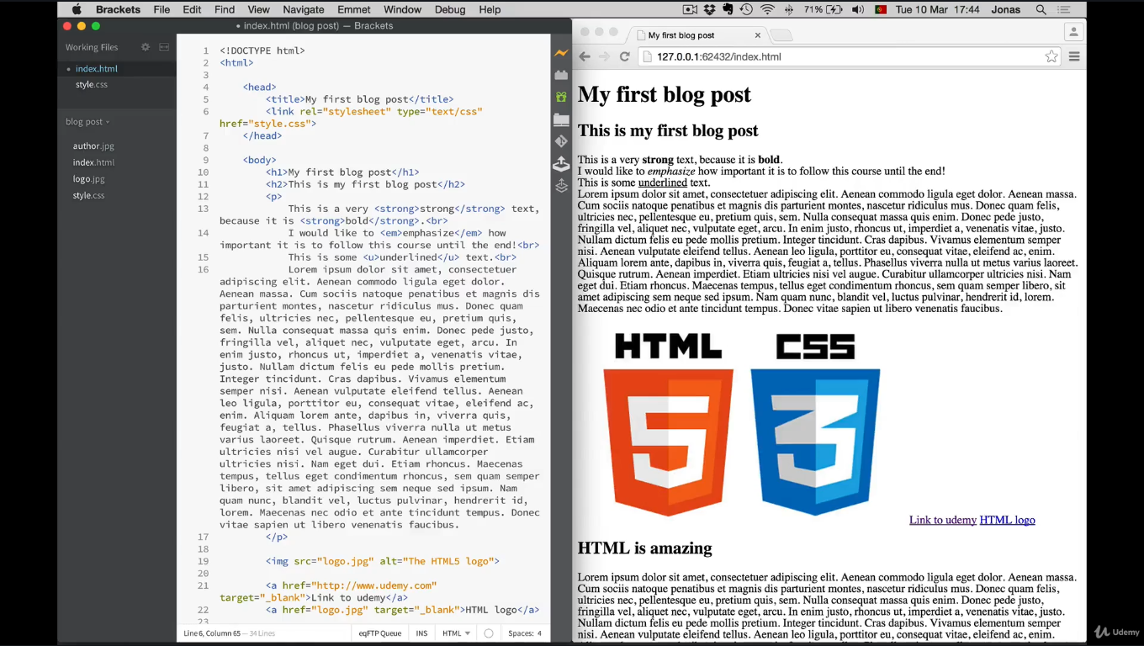

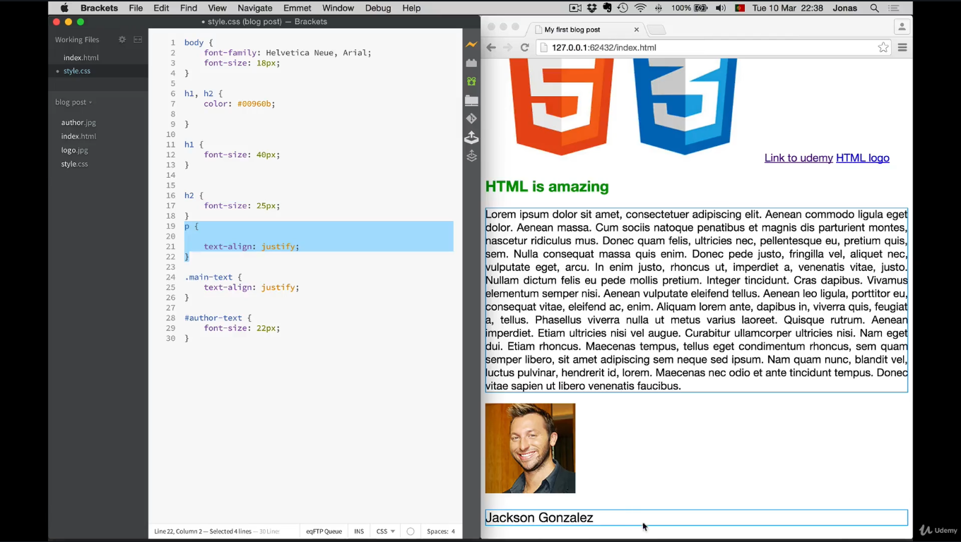

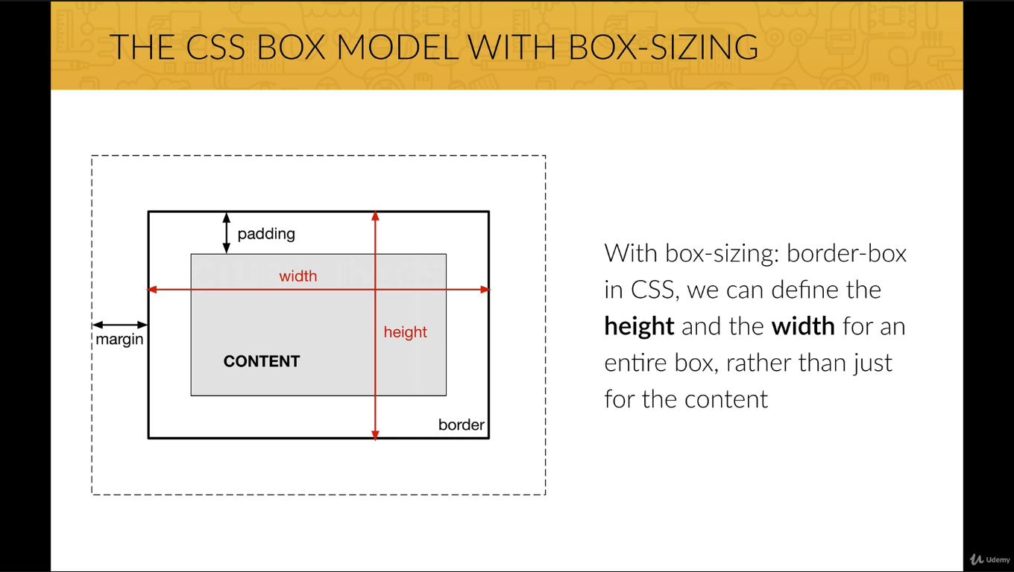

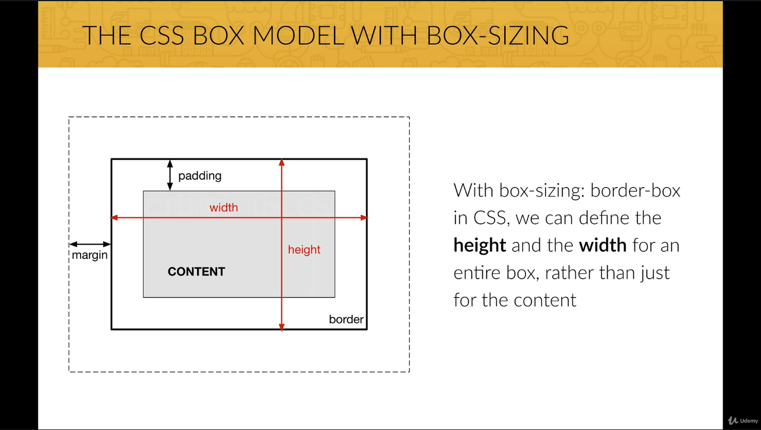

**Without the CSS box-sizing Property**

By default, the width and height of an element is calculated like this:

width + padding + border = actual width of an element  
height + padding + border = actual height of an element

This means: When you set the width/height of an element, the element often appears bigger than you have set (because the element's border and padding are added to the element's specified width/height).

The following illustration shows two <div> elements with the same specified width and height:

This div is smaller (width is 300px and height is 100px).

This div is bigger (width is also 300px and height is 100px).

## With the CSS box-sizing Property

The box-sizing property allows us to include the padding and border in an element's total width and height.

If you set box-sizing: border-box; on an element, padding and border are included in the width and height:

Both divs are the same size now!

Hooray!

Here is the same example as above, with box-sizing: border-box; added to both <div> elements:

### **Example**

.div1 {  
  width: 300px;  
  height: 100px;  
  border: 1px solid blue;  
  box-sizing: border-box;  
}  
  
.div2 {  
  width: 300px;  
  height: 100px;  
  padding: 50px;  
  border: 1px solid red;  
  box-sizing: border-box;  
}

[Try it Yourself »](https://www.w3schools.com/css/tryit.asp?filename=trycss3_box-sizing_new)

Since the result of using the box-sizing: border-box; is so much better, many developers want all elements on their pages to work this way.

The code below ensures that all elements are sized in this more intuitive way. Many browsers already use box-sizing: border-box; for many form

elements (but not all - which is why inputs and text areas look different at width: 100%;).

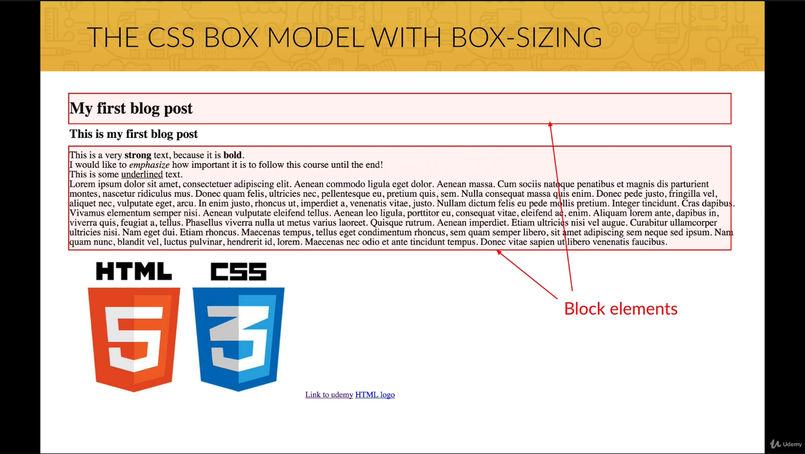

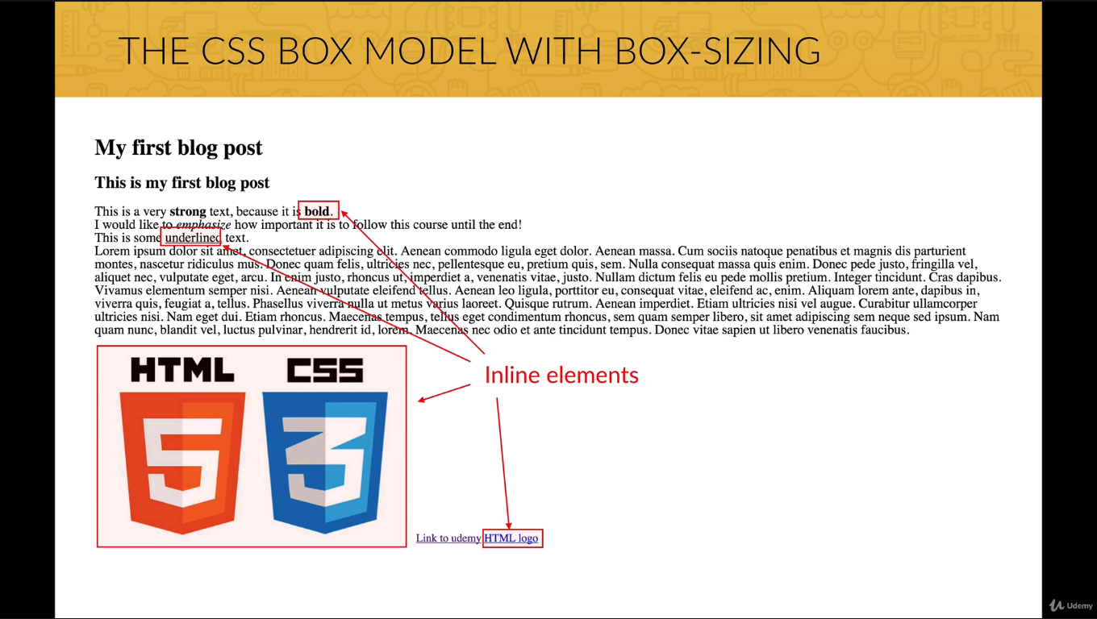

border: *border-width* *border-style* *border-color*|initial|inherit;

## Definition and Usage

The border property is a shorthand property for:

* [border-width](https://www.w3schools.com/cssref/pr_border-width.asp)
* [border-style](https://www.w3schools.com/cssref/pr_border-style.asp) (required)
* [border-color](https://www.w3schools.com/cssref/pr_border-color.asp)

If border-color is omitted, the color applied will be the color of the text.

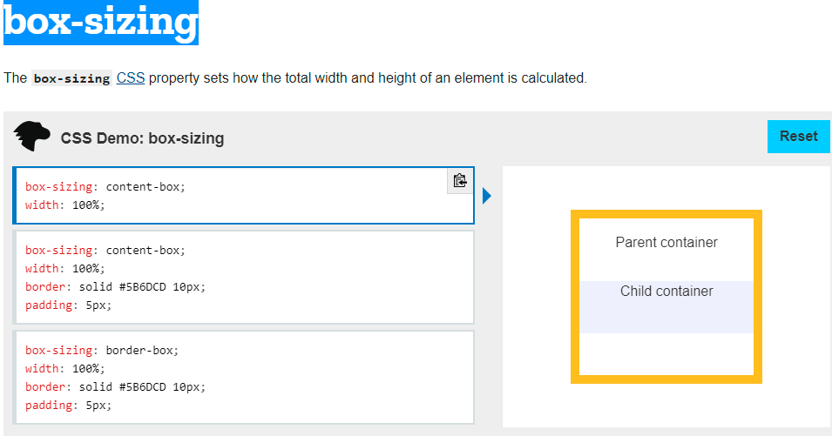

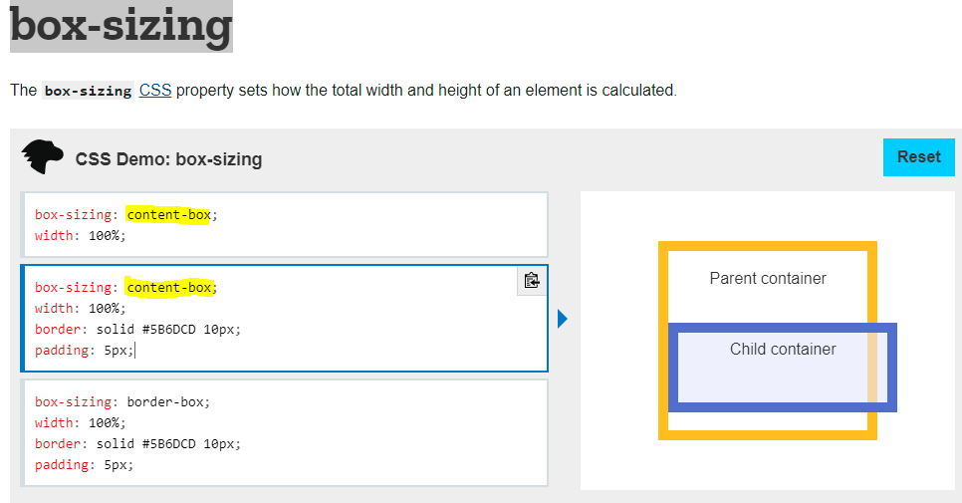

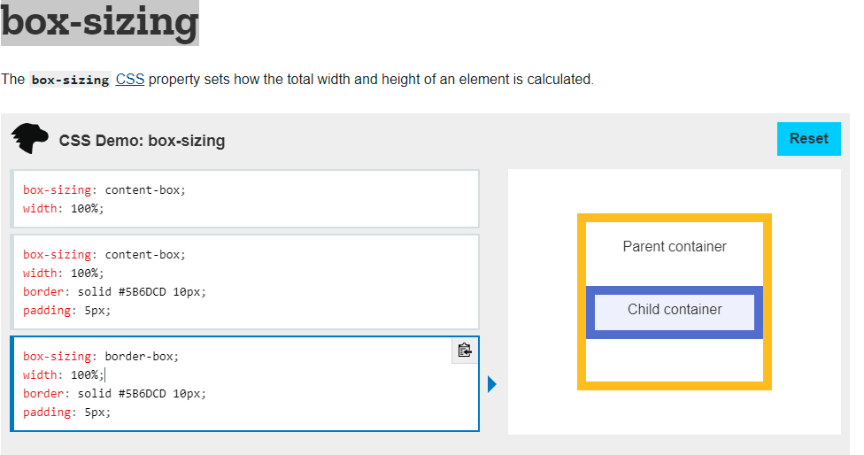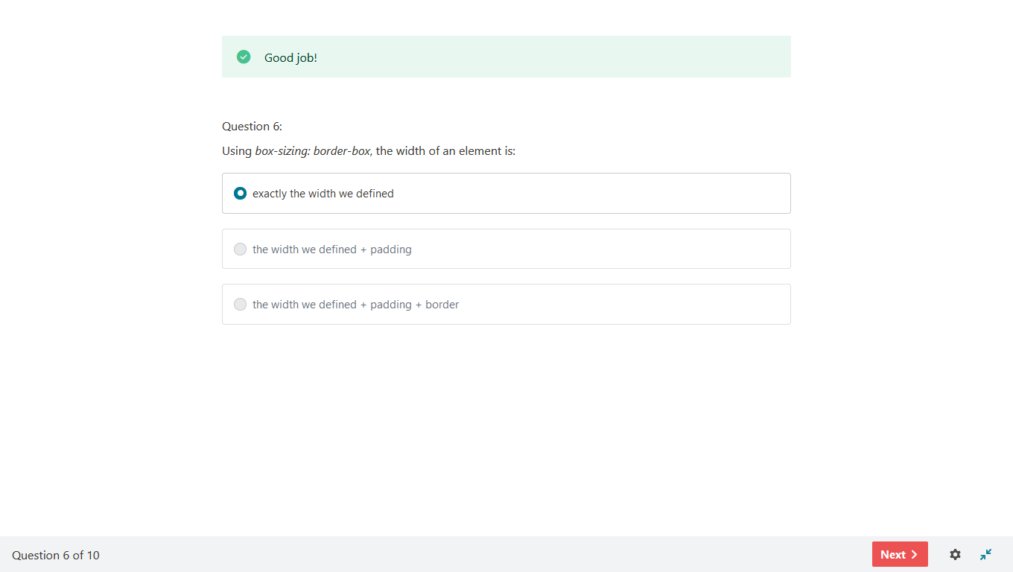

## [What is the CSS box model?](https://developer.mozilla.org/en-US/docs/Learn/CSS/Building_blocks/The_box_model#what_is_the_css_box_model)

The full CSS box model applies to block boxes, inline boxes only use some of the behavior defined in the box model. The model defines how the different parts of a box — margin, border, padding, and content — work together to create a box that you can see on the page. To add some additional complexity, there is a standard and an alternate box model.

### [**Parts of a box**](https://developer.mozilla.org/en-US/docs/Learn/CSS/Building_blocks/The_box_model#parts_of_a_box)

Making up a block box in CSS we have the:

* **Content box**: The area where your content is displayed, which can be sized using properties like [width](https://developer.mozilla.org/en-US/docs/Web/CSS/width) and [height](https://developer.mozilla.org/en-US/docs/Web/CSS/height).
* **Padding box**: The padding sits around the content as white space; its size can be controlled using [padding](https://developer.mozilla.org/en-US/docs/Web/CSS/padding) and related properties.
* **Border box**: The border box wraps the content and any padding. Its size and style can be controlled using [border](https://developer.mozilla.org/en-US/docs/Web/CSS/border) and related properties.
* **Margin box**: The margin is the outermost layer, wrapping the content, padding and border as whitespace between this box and other elements. Its size can be controlled using [margin](https://developer.mozilla.org/en-US/docs/Web/CSS/margin) and related properties.

The below diagram shows these layers:

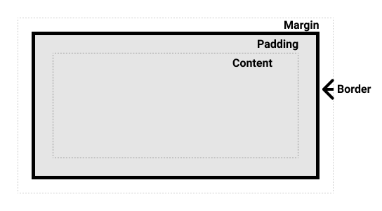

### [**The standard CSS box model**](https://developer.mozilla.org/en-US/docs/Learn/CSS/Building_blocks/The_box_model#the_standard_css_box_model)

In the standard box model, if you give a box a width and a height attribute, this defines the width and height of the content box. Any padding and border is then added to that width and height to get the total size taken up by the box. This is shown in the image below.

If we assume that the box has the following CSS defining width, height, margin, border, and padding:

.box {

width: 350px;

height: 150px;

margin: 10px;

padding: 25px;

border: 5px solid black;

}

The space taken up by our box using the standard box model will actually be 410px (350 + 25 + 25 + 5 + 5), and the height 210px (150 + 25 + 25 + 5 + 5), as the padding and border are added to the width used for the content box.

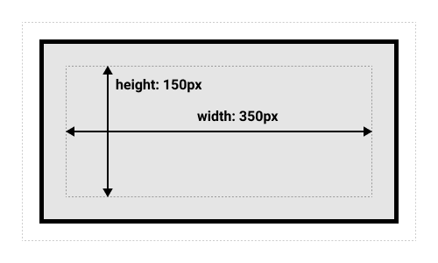

**Note**: The margin is not counted towards the actual size of the box — sure, it affects the total space that the box will take up on the page, but only the space outside the box. The box's area stops at the border — it does not extend into the margin.

### [**The alternative CSS box model**](https://developer.mozilla.org/en-US/docs/Learn/CSS/Building_blocks/The_box_model#the_alternative_css_box_model)

You might think it is rather inconvenient to have to add up the border and padding to get the real size of the box, and you would be right! For this reason, CSS had an alternative box model introduced some time after the standard box model. Using this model, any width is the width of the visible box on the page, therefore the content area width is that width minus the width for the padding and border. The same CSS as used above would give the below result (width = 350px, height = 150px).

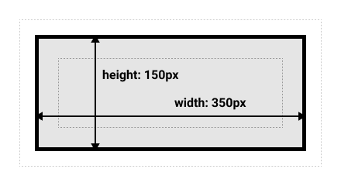

By default, browsers use the standard box model. If you want to turn on the alternative model for an element you do so by setting box-sizing: border-box on it. By doing this you are telling the browser to take the border box as the area defined by any size you set.

.box {

box-sizing: border-box;

}

If you want all of your elements to use the alternative box model, and this is a common choice among developers, set the box-sizing property on the <html> element, then set all other elements to inherit that value, as seen in the snippet below. If you want to understand the thinking behind this, see [the CSS Tricks article on box-sizing](https://css-tricks.com/inheriting-box-sizing-probably-slightly-better-best-practice/).

html {

box-sizing: border-box;

}

*, *::before, *::after {

box-sizing: inherit;

}

**Note**: An interesting bit of history — Internet Explorer used to default to the alternative box model, with no mechanism available to switch.

## [Playing with box models](https://developer.mozilla.org/en-US/docs/Learn/CSS/Building_blocks/The_box_model#playing_with_box_models)

In the below example, you can see two boxes. Both have a class of .box, which gives them the same width, height, margin, border, and padding. The only difference is that the second box has been set to use the alternative box model.

**Can you change the size of the second box (by adding CSS to the .alternate class) to make it match the first box in width and height?**

**Note**: You can find a solution for this task [here](https://github.com/mdn/css-examples/blob/master/learn/solutions.md#the-box-model).

By default in the [CSS box model](https://developer.mozilla.org/en-US/docs/Web/CSS/CSS_Box_Model/Introduction_to_the_CSS_box_model), the width and height you assign to an element is applied only to the element's content box. If the element has any border or padding, this is then added to the width and height to arrive at the size of the box that's rendered on the screen. This means that when you set width and height, you have to adjust the value you give to allow for any border or padding that may be added. For example, if you have four boxes with width: 25%;, if any has left or right padding or a left or right border, they will not by default fit on one line within the constraints of the parent container.

The box-sizing property can be used to adjust this behavior:

* content-box gives you the default CSS box-sizing behavior. If you set an element's width to 100 pixels, then the element's content box will be 100 pixels wide, and the width of any border or padding will be added to the final rendered width, making the element wider than 100px.
* border-box tells the browser to account for any border and padding in the values you specify for an element's width and height. If you set an element's width to 100 pixels, that 100 pixels will include any border or padding you added, and the content box will shrink to absorb that extra width. This typically makes it much easier to size elements.

The box-sizing property is specified as a single keyword chosen from the list of values below.

### [**Values**](https://developer.mozilla.org/en-US/docs/Web/CSS/box-sizing#values)

* **content-box**
* This is the initial and default value as specified by the CSS standard. The [width](https://developer.mozilla.org/en-US/docs/Web/CSS/width) and [height](https://developer.mozilla.org/en-US/docs/Web/CSS/height) properties include the content, but does not include the padding, border, or margin. For example, .box {width: 350px; border: 10px solid black;} renders a box that is 370px wide.
* Here, the dimensions of the element are calculated as: width = width of the content, and height = height of the content. (Borders and padding are not included in the calculation.)
* **border-box**
* The [width](https://developer.mozilla.org/en-US/docs/Web/CSS/width) and [height](https://developer.mozilla.org/en-US/docs/Web/CSS/height) properties include the content, padding, and border, but do not include the margin. Note that padding and border will be inside of the box. For example, .box {width: 350px; border: 10px solid black;} renders a box that is 350px wide, with the area for content being 330px wide. The content box can't be negative and is floored to 0, making it impossible to use border-box to make the element disappear.
* Here the dimensions of the element are calculated as: width = border + padding + width of the content, and height = border + padding + height of the content.

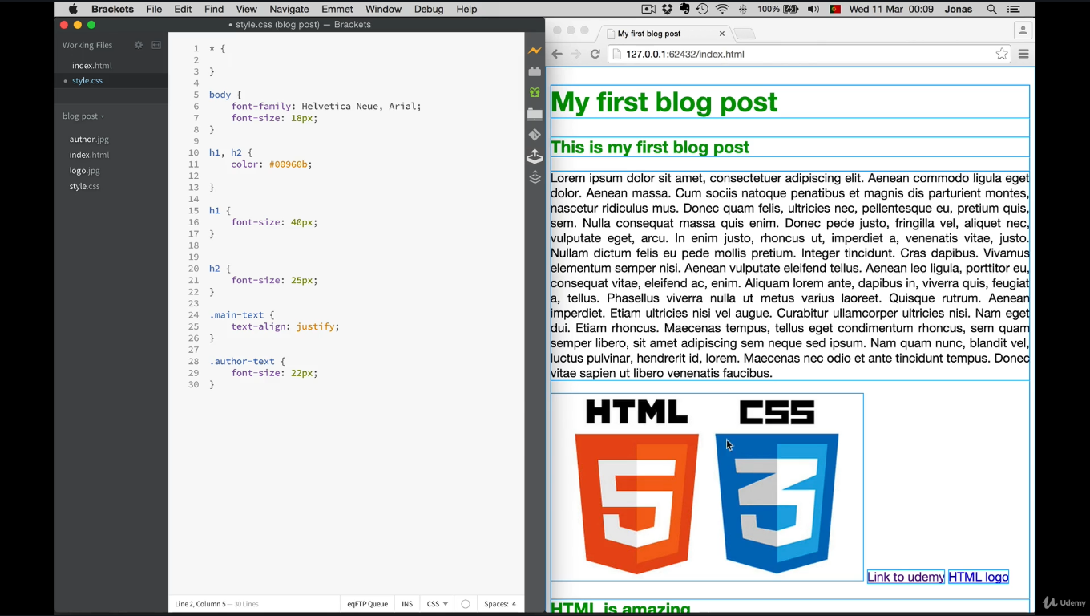

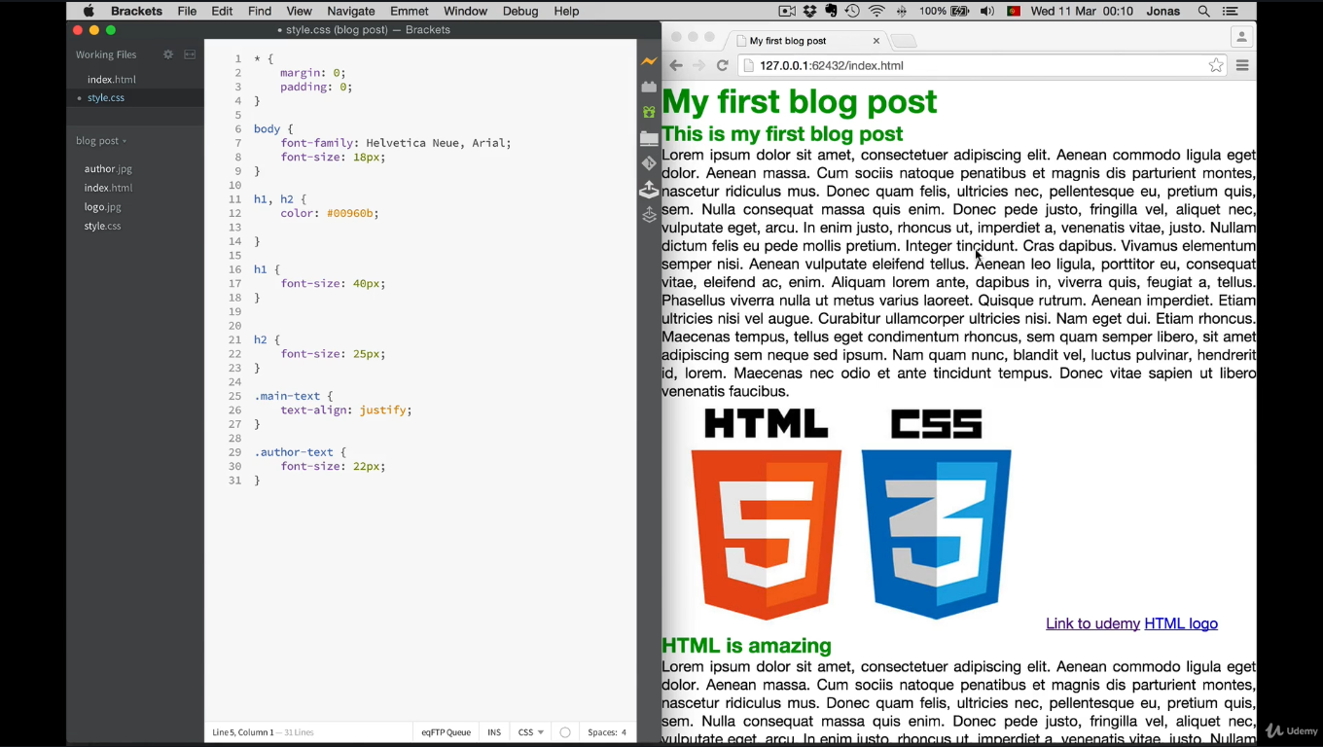

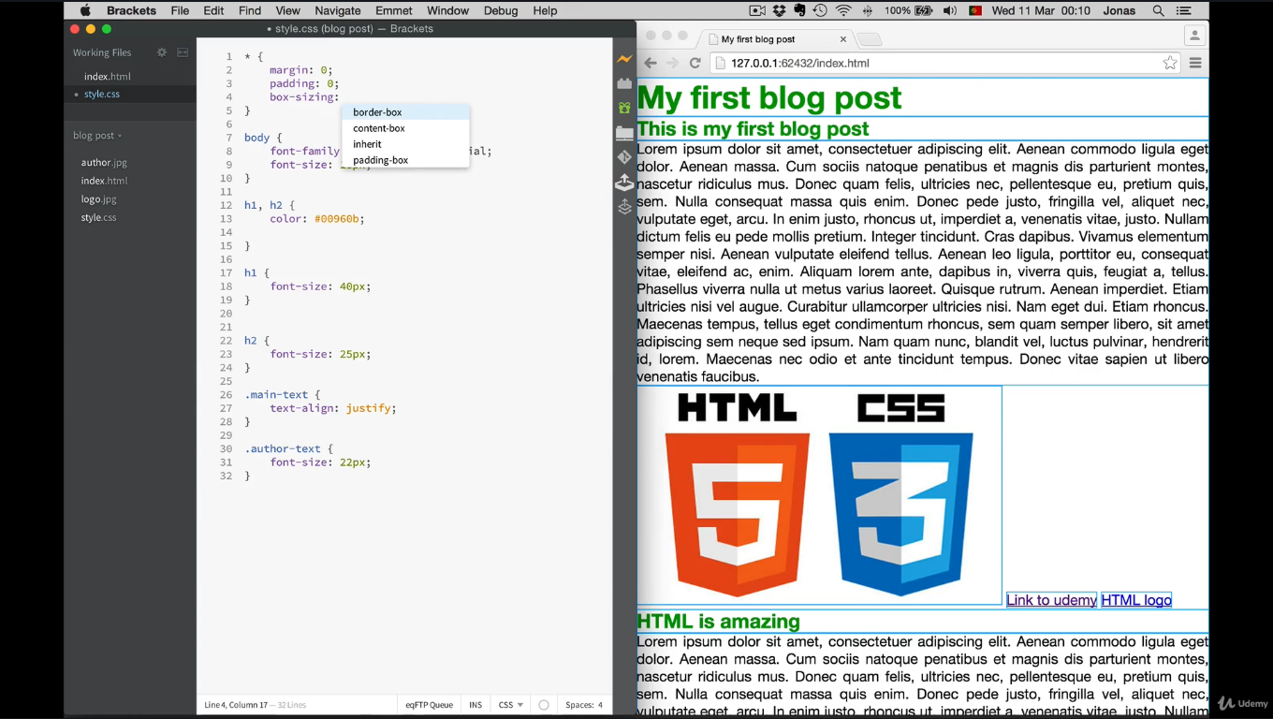

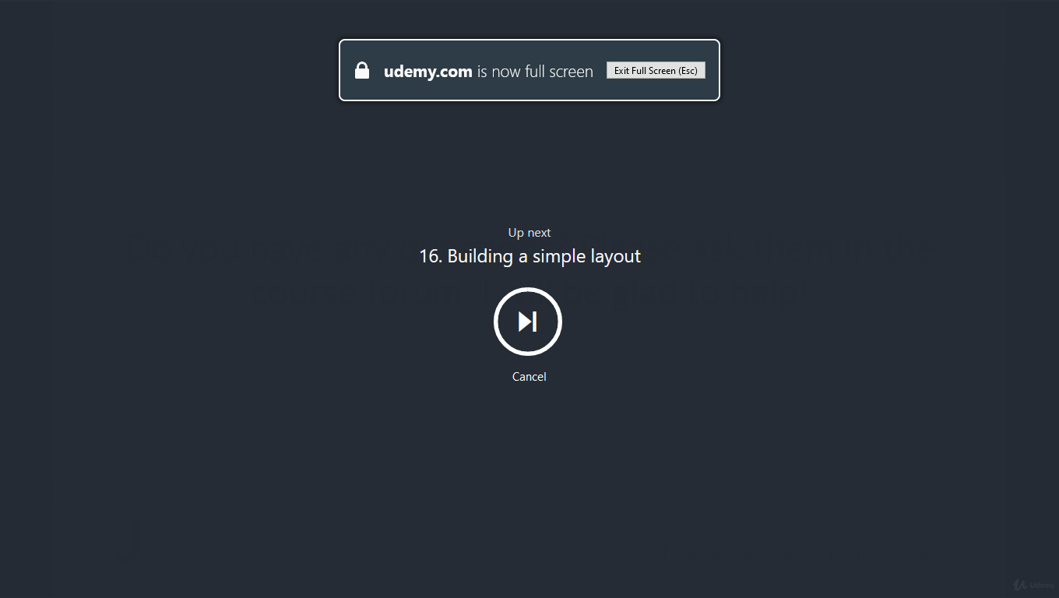

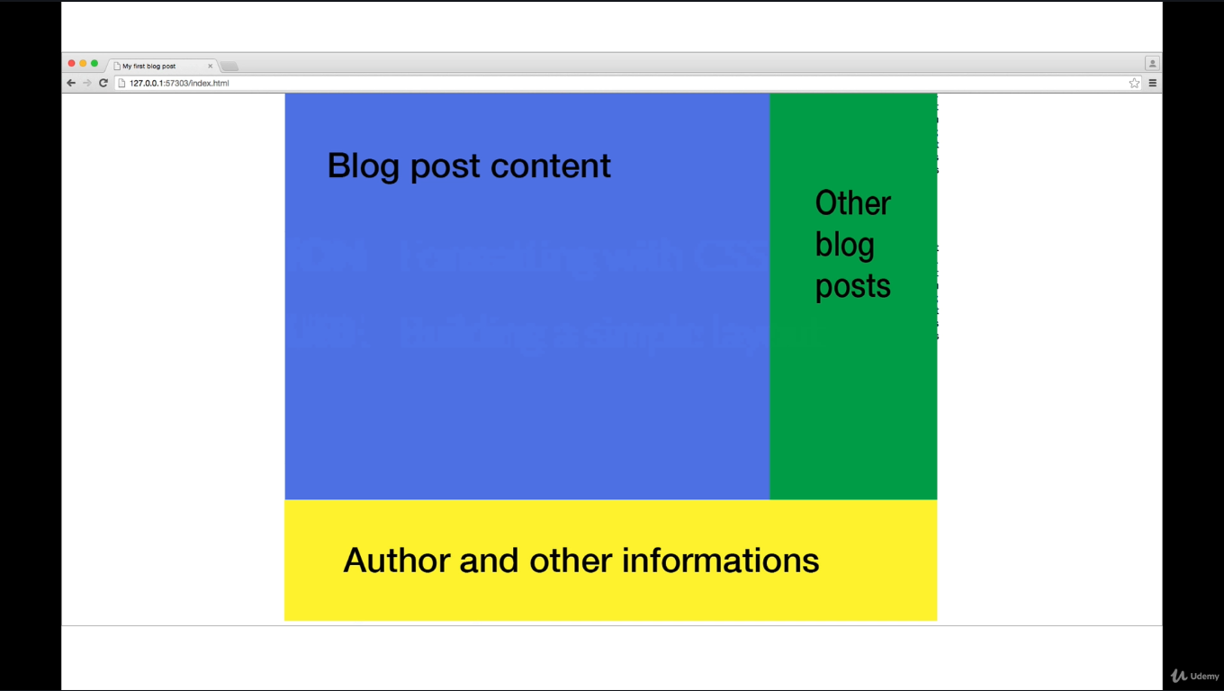

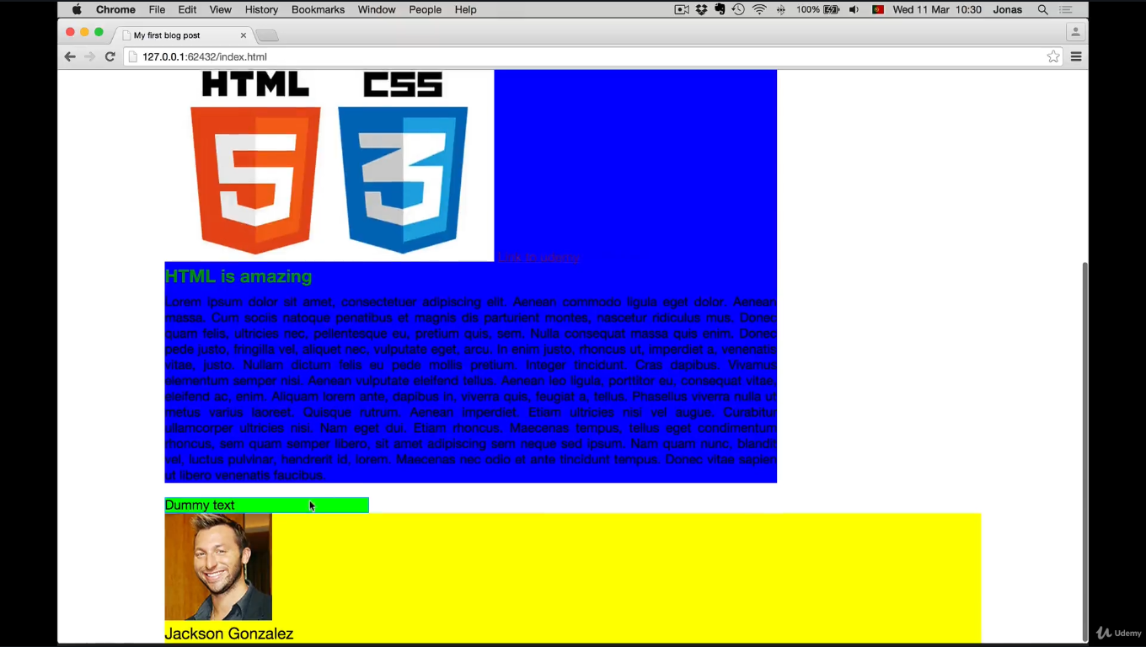

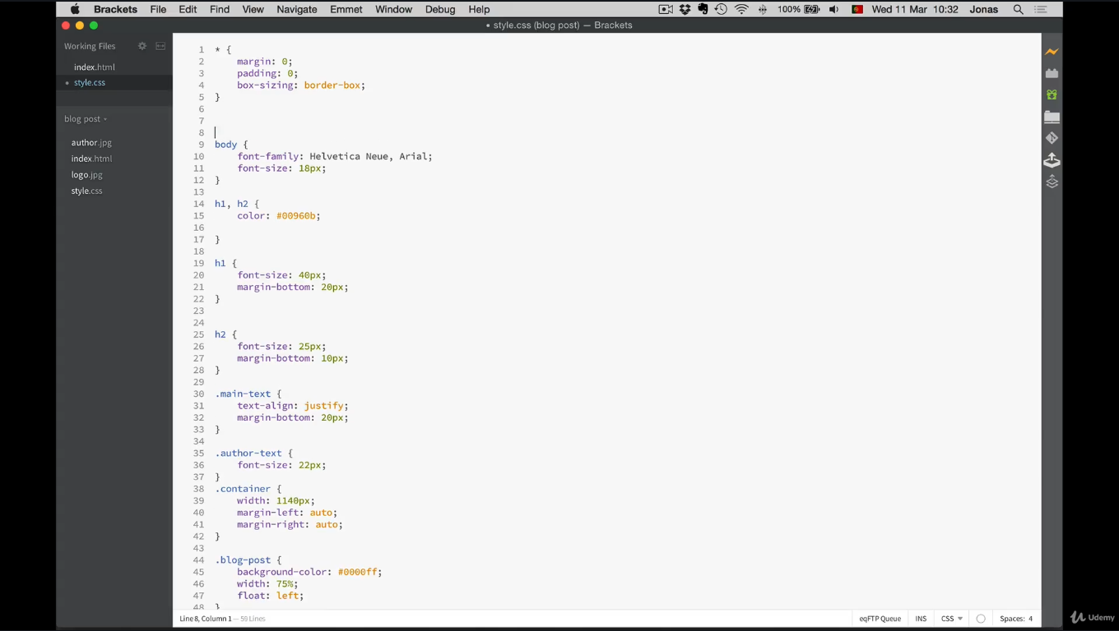

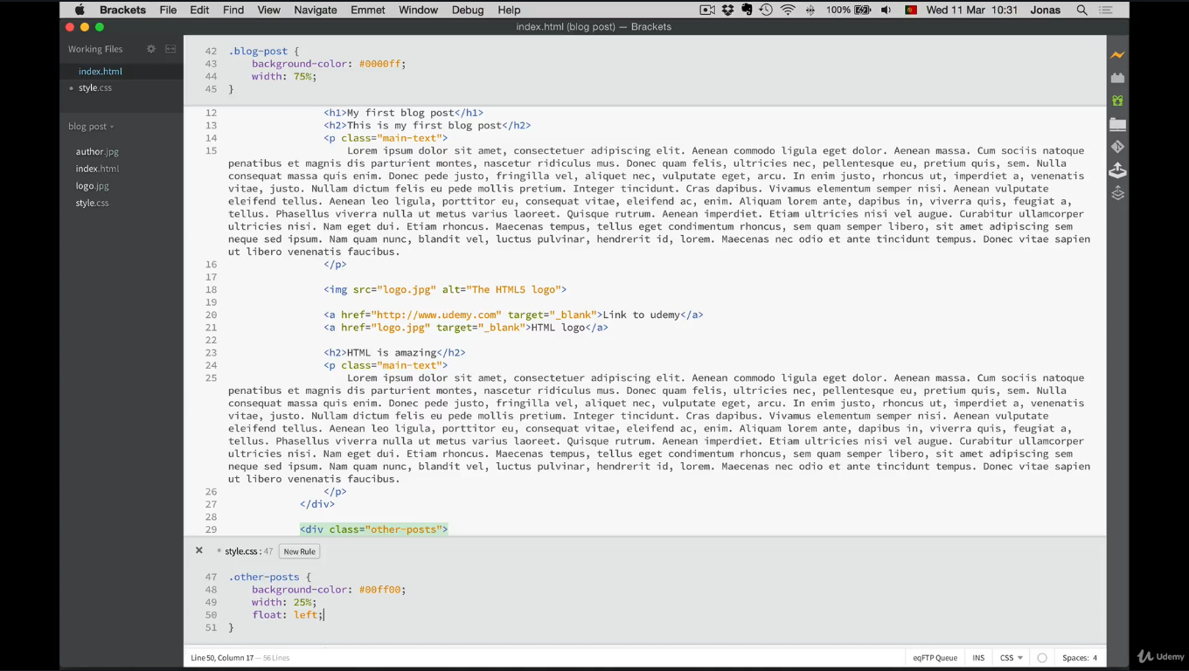

Float left for both blog-post and other-post

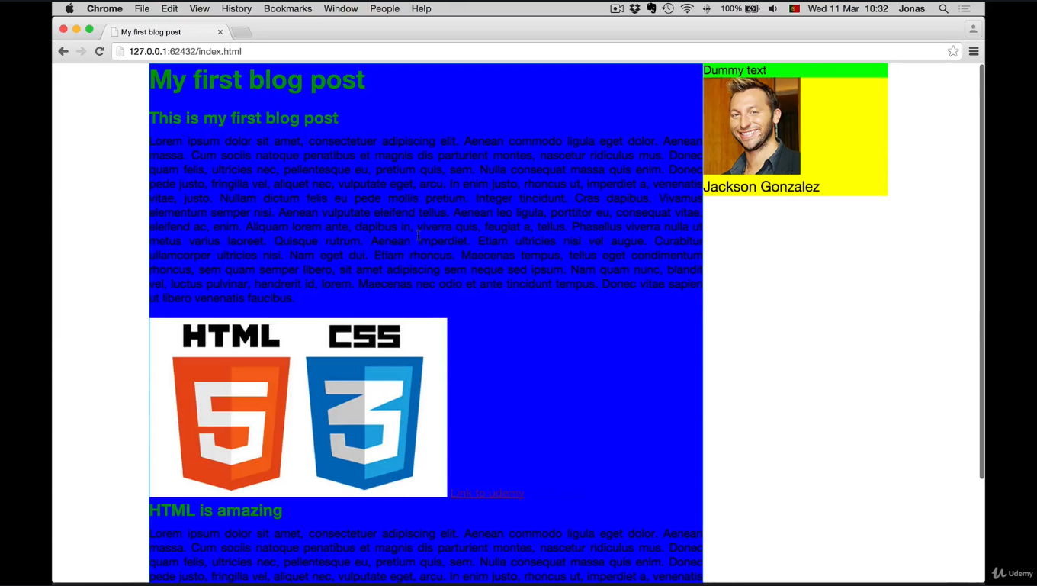

But there is a problem here yellow box is at right side but we need get this to bottom.

We’ll do it in specific way 1. Cleartext css and 2. Empty div

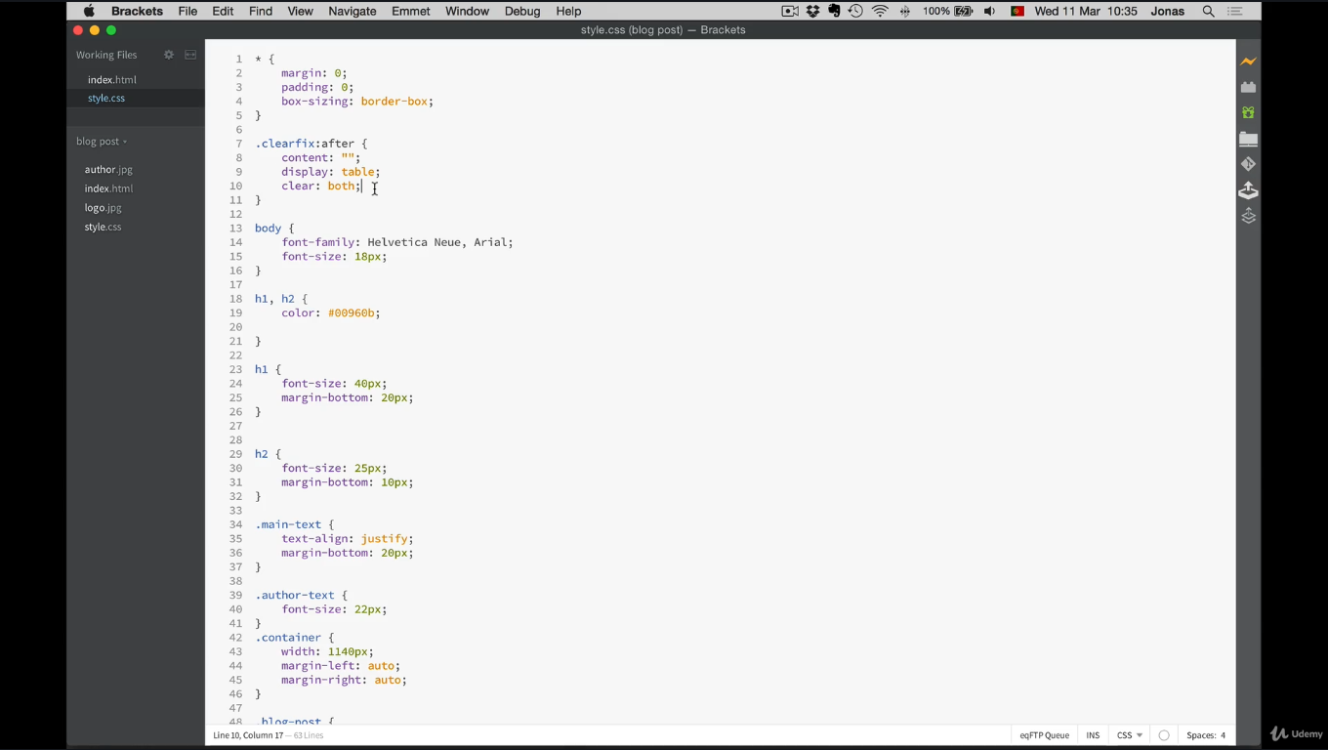

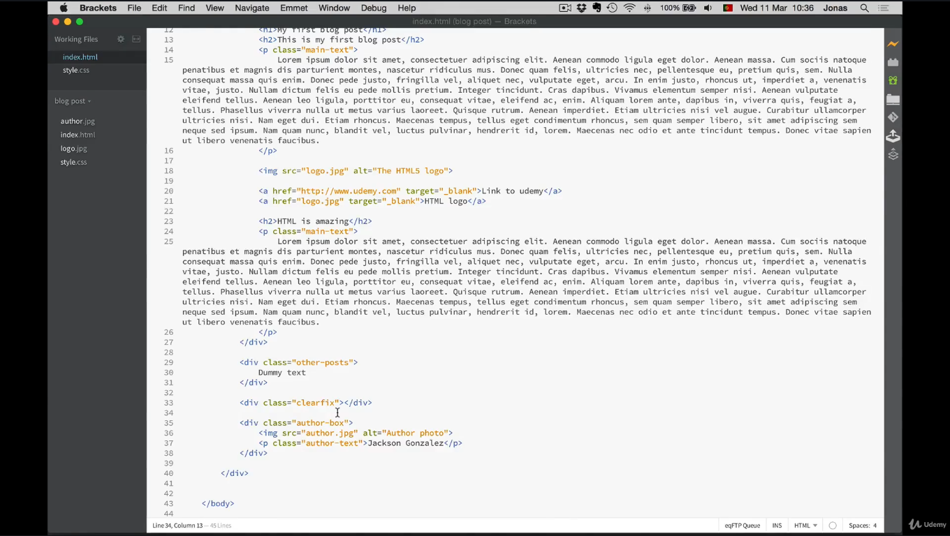

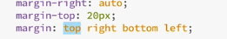

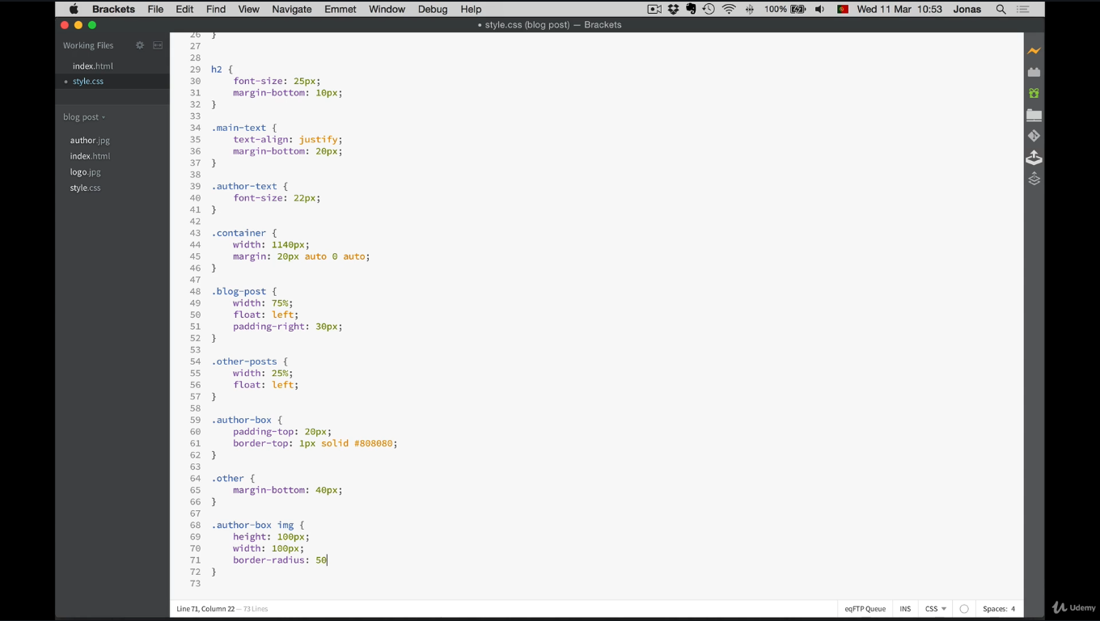

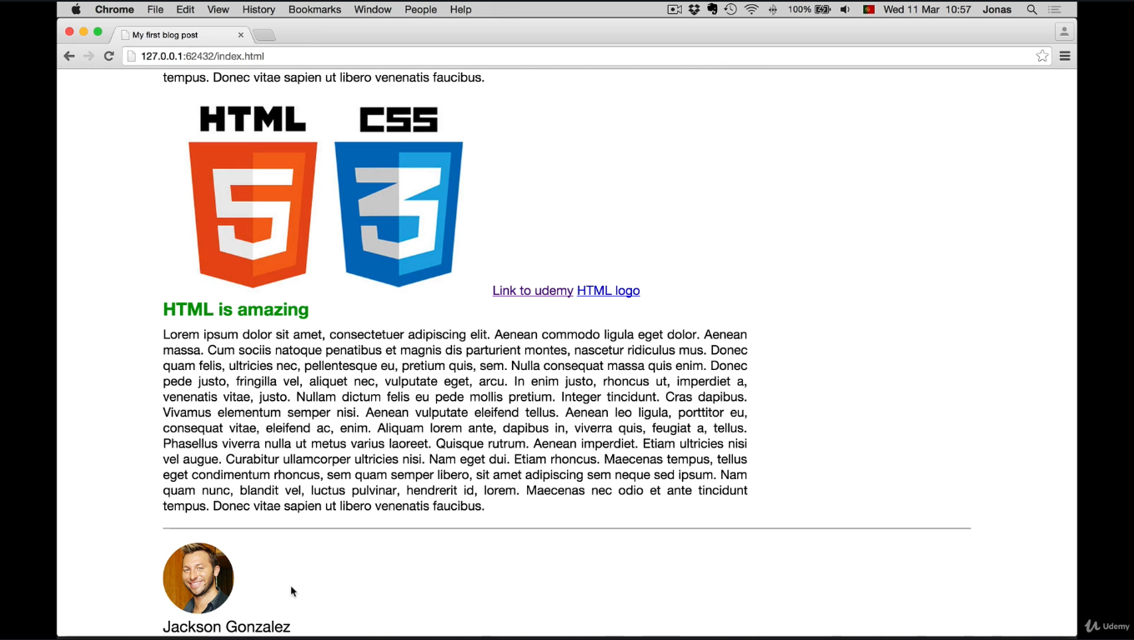

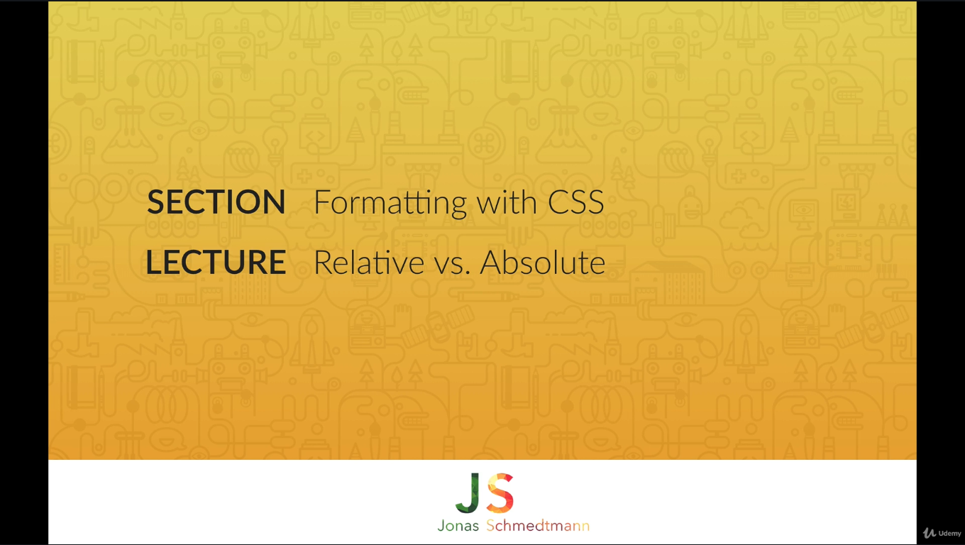

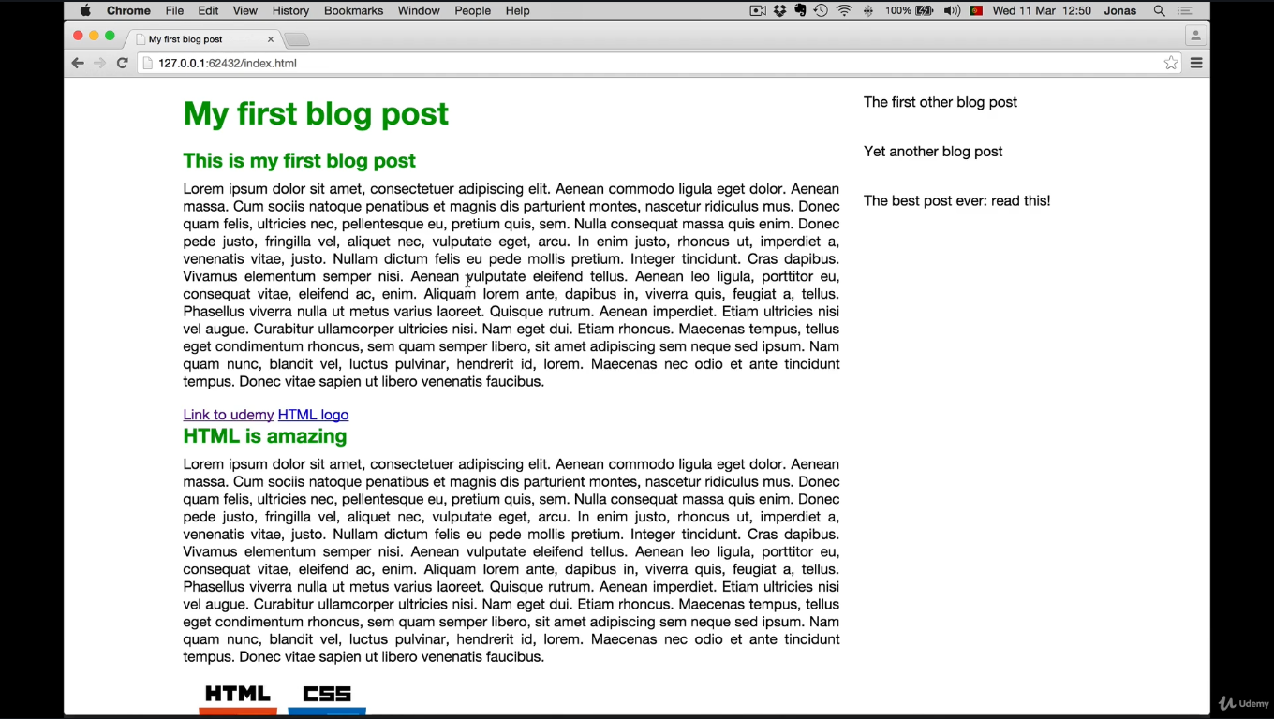

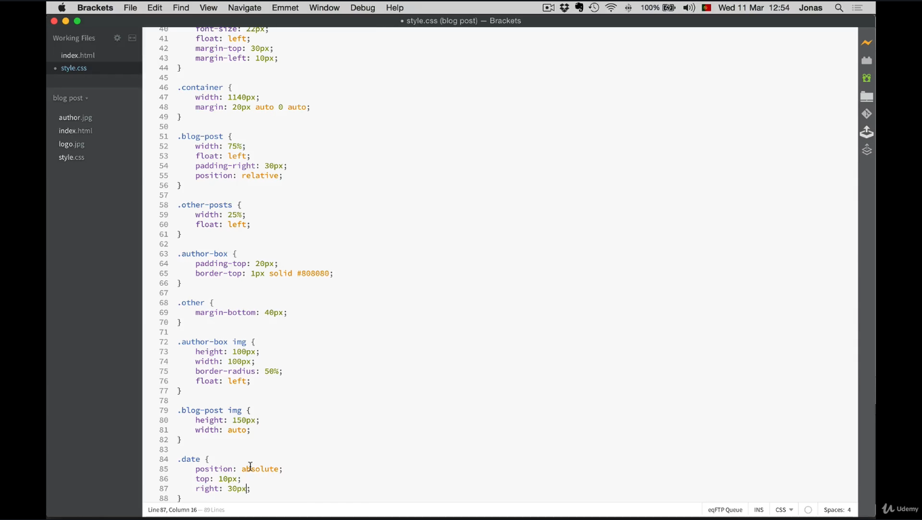

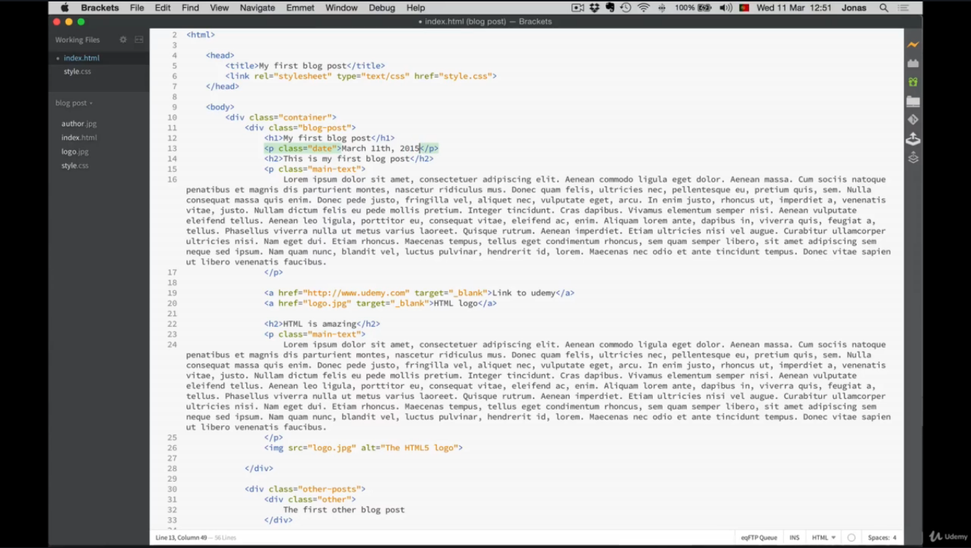

Blog-post and .date css has changes like position

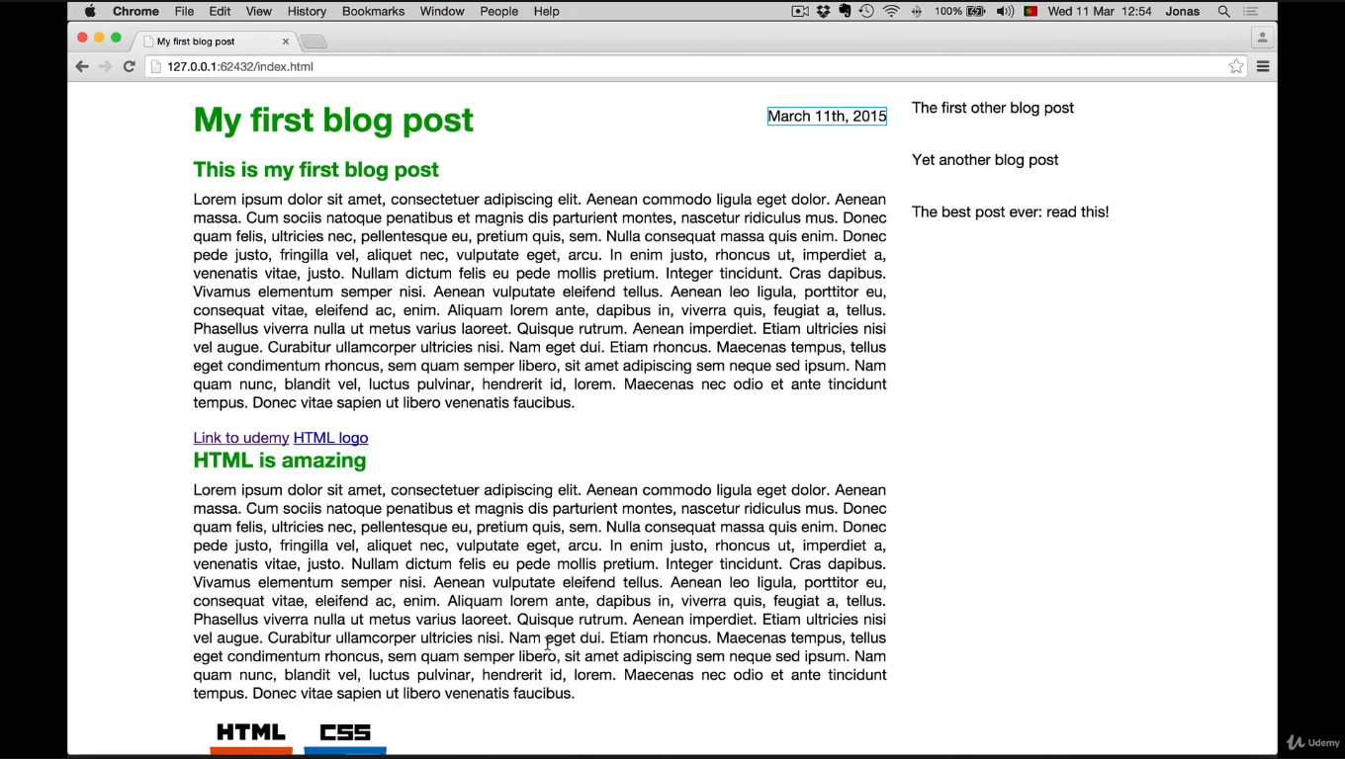

**display: inline to display: block or display: inline-flex to display: flex to toggle between these display modes.**

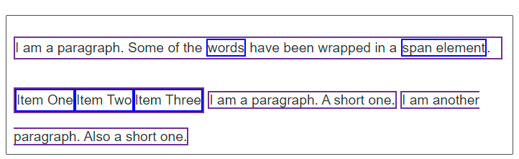

p,

ul {

border: 2px solid rebeccapurple;

}

span,

li {

border: 2px solid blue;

}

ul {

display:inline-flex;

list-style: none;

padding: 0;

}

.inline {

display: inline;

}

<p>

I am a paragraph. Some of the

<span>words</span> have been wrapped in a

<span>span element</span>.

</p>

<ul>

<li>Item One</li>

<li>Item Two</li>

<li>Item Three</li>

</ul>

<p class="inline">I am a paragraph. A short one.</p>

<p class="inline">I am another paragraph. Also a short one.</p>

<p>Veggies es bonus vobis, proinde vos postulo essum magis kohlrabi welsh onion daikon amaranth tatsoi tomatillo melon azuki bean garlic.</p>

## [What is overflow?](https://developer.mozilla.org/en-US/docs/Learn/CSS/Building_blocks/Overflowing_content#what_is_overflow)

Everything in CSS is a box. You can constrain the size of these boxes by assigning values of [width](https://developer.mozilla.org/en-US/docs/Web/CSS/width) and [height](https://developer.mozilla.org/en-US/docs/Web/CSS/height) (or [inline-size](https://developer.mozilla.org/en-US/docs/Web/CSS/inline-size) and [block-size](https://developer.mozilla.org/en-US/docs/Web/CSS/block-size)). **Overflow happens when there is too much content to fit in a box.** CSS provides various tools to manage overflow. As you go further with CSS layout and writing CSS, you will encounter more overflow situations.

## [CSS tries to avoid "data loss"](https://developer.mozilla.org/en-US/docs/Learn/CSS/Building_blocks/Overflowing_content#css_tries_to_avoid_data_loss)

Let's consider two examples that demonstrate the default behavior of CSS when there is overflow.

The first example is a box that has been restricted by setting a height. Then we add content that exceeds the allocated space. The content overflows the box and falls into the paragraph below.

The second example is a word in a box. The box has been made too small for the word and so it breaks out of the box.

You might wonder why CSS works in such a messy way, displaying content outside of its intended container. Why not hide overflowing content? Why not scale the size of the container to fit all the content?

Wherever possible, CSS does not hide content. This would cause data loss. The problem with data loss is that you might not notice. Website visitors may not notice. If the submit button on a form disappears and no one can complete the form, this could be a big problem! Instead, CSS overflows in visible ways. You are more likely to see there is a problem. At worst, a site visitor will let you know that content is overlapping.

If you restrict a box with a width or a height, CSS trusts you to know what you are doing. CSS assumes that you are managing the potential for overflow. In general, restricting the block dimension is problematic when the box contains text. There may be more text than you expected when designing the site, or the text may be larger. (for example, if the user has increased their font size)

The next two lessons explain different approaches to control sizing in ways that are less prone to overflow. However, if you need a fixed size, you can also control how the overflow behaves. Let's read on!

## [The overflow property](https://developer.mozilla.org/en-US/docs/Learn/CSS/Building_blocks/Overflowing_content#the_overflow_property)

The  [overflow](https://developer.mozilla.org/en-US/docs/Web/CSS/overflow) property is how you take control of an element's overflow. It is the way you instruct the browser how it should behave. The default value of overflow is visible. With this default, we can see content when it overflows.

To crop content when it overflows, you can set overflow: hidden. This does exactly what it says: it hides overflow. Beware that this can make some content invisible. You should only do this if hiding content won't cause problems.

Instead, perhaps you would like to add scrollbars when content overflows? Using overflow: scroll, browsers with visible scrollbars will always display them—even if there is not enough content to overflow. This offers the advantage of keeping the layout consistent, instead of scrollbars appearing or disappearing, depending upon the amount of content in the container.

**Remove some content from the box below. Notice how the scrollbars remain, even if there is no need for scrolling.**

In the example above, we only need to scroll on the y axis, however we get scrollbars in both axes. To just scroll on the y axis, you could use the [overflow-y](https://developer.mozilla.org/en-US/docs/Web/CSS/overflow-y) property, setting overflow-y: scroll.

You can also scroll on the x axis using [overflow-x](https://developer.mozilla.org/en-US/docs/Web/CSS/overflow-x), although this is not a recommended way to accommodate long words! If you have a long word in a small box, you might consider using the [word-break](https://developer.mozilla.org/en-US/docs/Web/CSS/word-break) or [overflow-wrap](https://developer.mozilla.org/en-US/docs/Web/CSS/overflow-wrap) properties. In addition, some of the methods discussed in [Sizing items in CSS](https://developer.mozilla.org/en-US/docs/Learn/CSS/Building_blocks/Sizing_items_in_CSS) may help you create boxes that scale better with varying amounts of content.

As with scroll, you get a scrollbar in the scrolling dimension whether or not there is enough content to cause a scrollbar.

**Note**: You can specify x and y scrolling using the overflow property, passing two values. If two keywords are specified, the first applies to overflow-x and the second applies to overflow-y. Otherwise, both overflow-x and overflow-y are set to the same value. For example, overflow: scroll hidden would set overflow-x to scroll and overflow-y to hidden.

If you only want scrollbars to appear when there is more content than can fit in the box, use overflow: auto. This allows the browser to determine if it should display scrollbars.

**In the example below, remove content until it fits into the box. You should see the scrollbars disappear.**

## [Overflow establishes a Block Formatting Context](https://developer.mozilla.org/en-US/docs/Learn/CSS/Building_blocks/Overflowing_content#overflow_establishes_a_block_formatting_context)

When you use a value of overflow such as scroll or auto, you create a **Block Formatting Context** (BFC). The content of the box that you have changed the value of overflow for acquires a self-contained layout. Content outside the container cannot poke into the container, and nothing can poke out of that container into the surrounding layout. This enables scrolling behavior, as all box content needs to be contained and not overlap, in order to create a consistent scrolling experience.